**Supplementary file**

Development of biodegradable chlorhexidine-functionalized polyurethane nanofibers for antimicrobial applications

Ahmed Abd El-Fattah1,2,*,Hend Ramadan1, Labiba El-Khordagui3 and Sherif Kandil1

*1 Department of Materials Science, Institute of Graduate Studies and Research, Alexandria University, El-Shatby, 21526, Alexandria, Egypt*

*2 Department of Chemistry, College of Science, University of Bahrain, P.O. Box 32038, Sakhir, Kingdom of Bahrain*

*3 Department of Pharmaceutics, Faculty of Pharmacy, Alexandria University*

1. **Introduction**

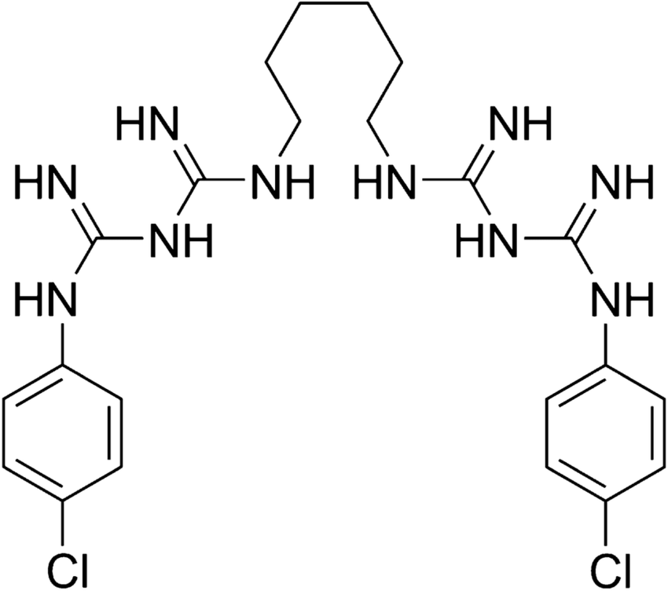

**Figure 1S.** Chemical structure of chlorhexidine

1. **Results and Discussion**

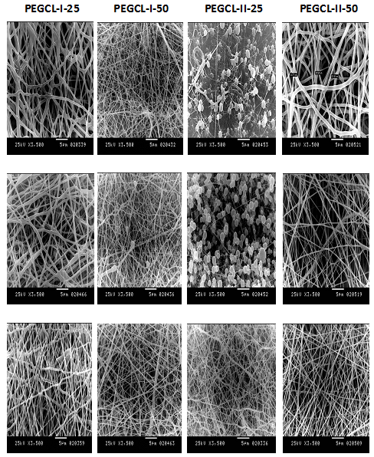

**Figure 2S**. Effect of the solvent type on the morphological properties of copolymer nanofibers electrospun at 20kV, 0.5 ml/h flow rate and 10 cm collecting distance.

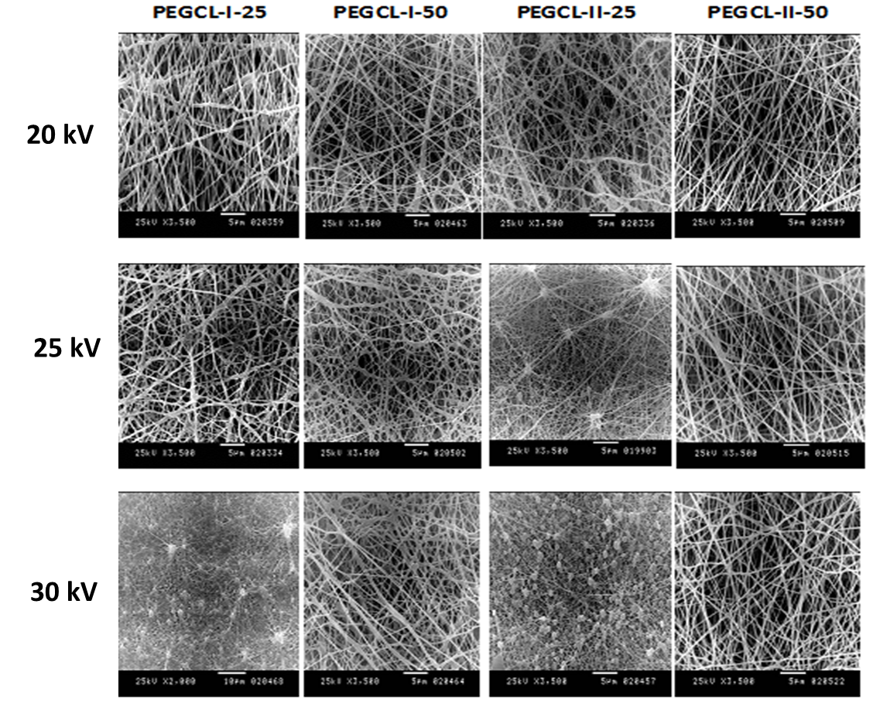

**Figure 3S**. Effect of the applied voltage on the morphological properties of copolymer nanofibers electrospun using DCM /DMF 4: 1, 0.5 ml/h flow rate and 10 cm collecting distance.

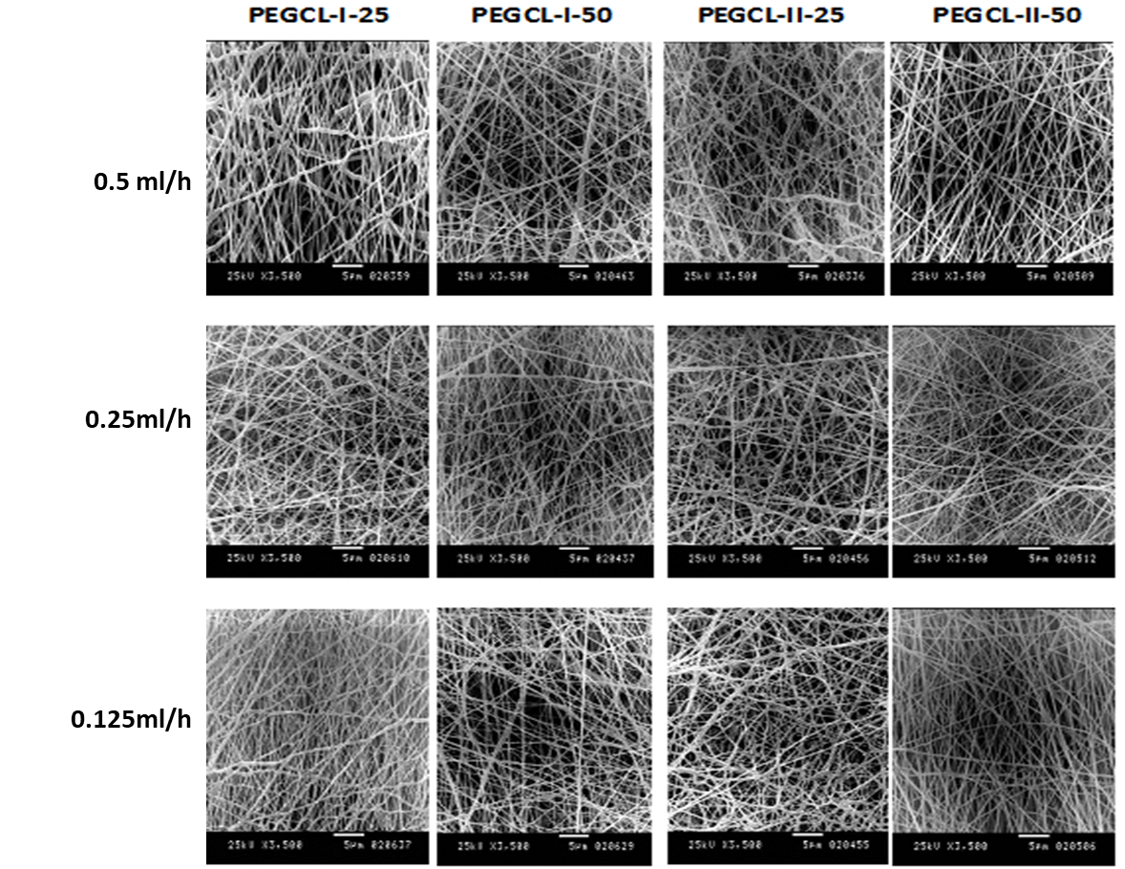

**Figure 4S.** Effect of the flow rate copolymer solution in DCM / DMF 4: 1 on the morphological properties of copolymer nanofibers electrospun at 20kV, 0.5 ml/h flow rate and 10 cm collection distance.

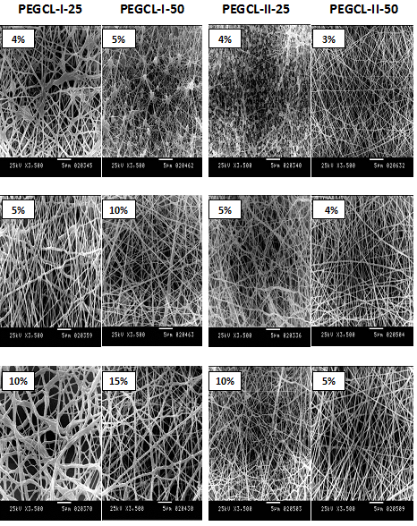

**Figure 5S.** Effect of copolymer solution concentration in DCM/DMF (4: 1) on the morphological properties of nanofibers electrospun at 20 kV, 0.5 ml/h flow rate and 10 cm collecting distance.